Dear Retreatant,
Thank you for your interest in the upcoming Spiritual Exercises directed and preached by the priests of Miles Christi. Praised by popes and saints throughout the centuries, the Spiritual Exercises are an excellent means of sanctification. As Pope St. John Paul II expressed, “the Exercises are, in fact, a set of meditations and prayers in an atmosphere of contemplation and silence, and, above all, a special interior impulse—deriving from the Holy Spirit—to open ample spaces of the soul to the action of grace.”
The highest quality of the Exercises lies in the power they have to lead men to the very summit of prayer and divine love. This is shown, through experience, by the changes in moral conduct that a single Ignatian retreat has affected in the lives of thousands of people throughout history. Among the saints, St. Charles Borromeo was led by the Exercises “to adopt a more perfect form of life,” St. Francis de Sales “to serve God with the greatest possible fidelity,” and St. Teresa of Jesus to become “the lover of lofty contemplation.”
The retreat begins on Friday, January 20, 2023 at The Prince of Peace Abbey in Oceanside, California. Driving directions included in a separate attachment and are downloadable from our website. Registration begins at 4:00pm. Friday’s schedule includes Holy Mass and dinner. The last event is Sunday Mass, which will end by 5:00pm.
We try to keep the cost as affordable as possible. The fee includes the retreat house rental, room and board, meals, and a minimum expense for the preachers’ transportation. No preacher stipend is taken into account. The cost for single occupancy accommodations is $330.00. The number of spaces is limited on this retreat. We encourage you to submit your registration form as soon as possible to secure your reservation.
Some considerations for your retreat:
- All the spiritual talks of this directed retreat will be presented by the priests of Miles Christi and are in complete faithfulness to the Magisterium and tradition of the Catholic Church.
- Registration options: 1.) Online registration via credit or debit card at: www.mileschristi.org/spiritual-exercises or 2.) Print out, fill in and mail the registration form along with a check made payable to Miles Christi to Miles Christi Religious Order. Its submission will reserve your spot.
- If you are flying to the retreat, San Diego International Airport is the closest major airport.
- Please let us know if transportation help from the airport to the retreat house is needed.
- After each spiritual talk, a time of personal meditation is scheduled. Since the priests encourage attending the Ignatian retreat annually, every year a new set of Ignatian talks are presented.
- Other important elements of this retreat are the reverent celebration of the Holy Mass, Solemn Eucharistic Adoration and Benediction, visits to the Blessed Sacrament, the Holy Rosary and Stations of the Cross. Besides offering the Sacrament of Confession, the priests of Miles Christi will be available to meet individually throughout the retreat. This is another helpful tool for making your retreat more fruitful.
- Please bring your Bible, Rosary and a notebook, as well as toiletries. The retreat house provides towels and bed linens. St. Ignatius’ book of the Spiritual Exercises and The Imitation of Christ will be available for your use. You do not need to bring any other spiritual book.
- Silence throughout the retreat is an expressed stipulation of St. Ignatius. You will find that the external silence helps to create an environment of recollection and devotion that allows God to do great works within your soul. Retreatants are expected to follow the schedule of the retreat.
- Gabriela Spartz is handling registrations and details of this retreat. You may contact her at (619) 745-5429 or california@spiritualexercises.net
- Important: If, unfortunately, you must cancel at the last minute, please call Gabriela at (619) 745-5429. We may be able to accommodate someone else who would like to attend.
If you would like to learn more about Miles Christi and our nationwide Spiritual Exercises apostolate, please visit our website at www.mileschristi.org.
We encourage you to begin your spiritual preparation and to pray for the success of this retreat. We also encourage you to invite others to attend. We are confident that you will draw abundant spiritual fruits from these heavenly days. Be assured of our prayers as you prepare with enthusiasm for this silent Ignatian retreat.
Sincerely yours in Christ,
The Priests of Miles Christi

Miles Christi Religious Order - Ph: (858) 768-0872 – infowest@mileschristi.org - www.mileschristi.org

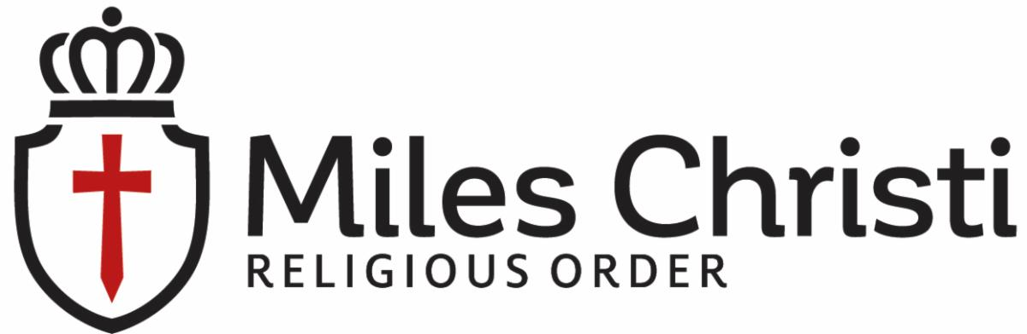 Spiritual Exercises - Silent Ignatian Retreat
REGISTRATION FORM
January 20-22, 2023 – Oceanside, California - Women
Ms. Mrs. Dr. Other (please specify: ________)
Name: ____________________________________________________ Phone: (_____) ____-__________
First Middle Last Home or Cell
Address: _______________________________ _____________________ ______ ___________
Street City State Zip Code
Email: ____________________________________________________ Parish: ________________________

Year of Birth (optional): ____________ Occupation: ______________________________________________

Room Preference: (check one): Single $330 Double $280
I would also like to include $_____ as a donation to help others attend the Spiritual Exercises.
(Please make check payable to “Miles Christi” and add to the memo line, “CAWSE Retreat Reg.”)

Have you ever made the Spiritual Exercises? No Yes With Miles Christi Other?___________________

How did you hear about this retreat? Newspaper/Friend/Relative/Conference - Please specify below:
________________________________________________________________________________________________________
Add here any special requirement you need for the weekend (special diet, allergies etc.) or any helpful information:
________________________________________________________________________________________________________
In case of emergency during the retreat we should contact:
________________________________________ __________________________ _______________
Name Phone Relationship
Registration deadline is January 6, 2023

This form can be mailed or e-mailed. Please call Gabriela Spartz if you would like to pay by credit card or visit www.mileschristi.org/spiritual-exercises. Mail this form and check payment to the address below.

Miles Christi Religious Order Phone: (619) 745-5429
5677 Oberlin Drive E-mail: california@spiritualexercises.net
Suite 200
San Diego, CA 92191

NOTE: You will receive a confirmation of your registration by phone or email. Thank you!
www.mileschristi.org
Please do not write below this line - for office use

